Name: Vidya Ganesan

Batch Number: LISUM06

Submission Date: 15 March 2022

Submitted URL: https://github.com/vidya-ganesan/deplyment-on-heroku-pdf-format

**Deployment on Flask in python**

**Step 1:** Import the necessary python libraries to run the model.

**Step 2:** Develop ML model.

Select a dataset. Predict the salary of an employee based on years of experience, test score and interview score using linear regression.





**Step 3**: **Saving the ML model to the disk using pickle library**



**Step 4**: **Deployment of model in flask**





**Step 5:** **Creating the web app by typing the URL in the browser.**

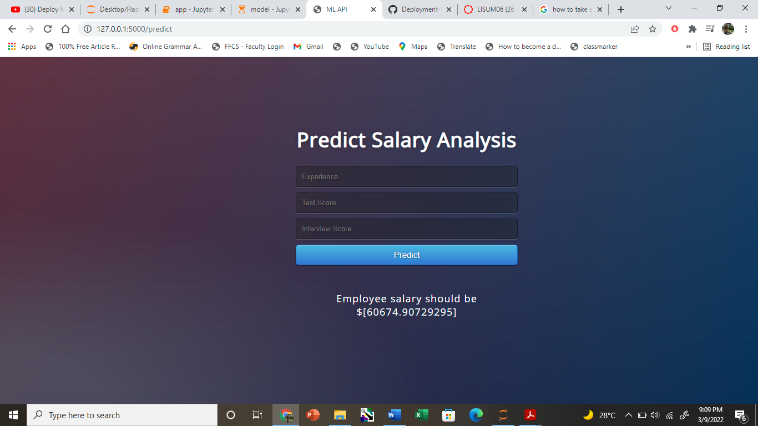

**Step 6:**

* Created **Procfile** file which contain the command to execute the Heroku app on startup.
* Created a requirement.txt file which contains the dependencies for the flask app.

**Step 7: Create a new repository in GitHub and commit the code to the repository.**

**URL:** [**https://github.com/vidya-ganesan/deployment-on-heroku**](https://github.com/vidya-ganesan/deployment-on-heroku)

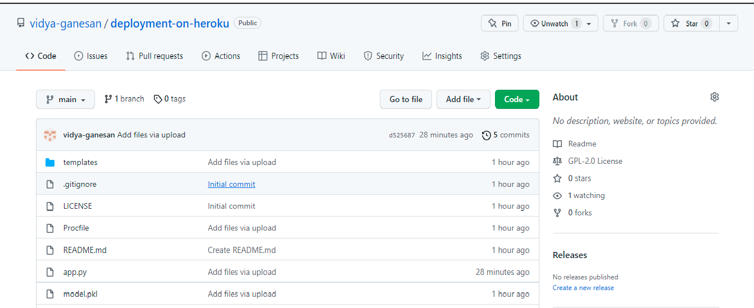

**Step 8: Open Heroku app.com and then create a new account and login and create a new app in the name prediction-21**

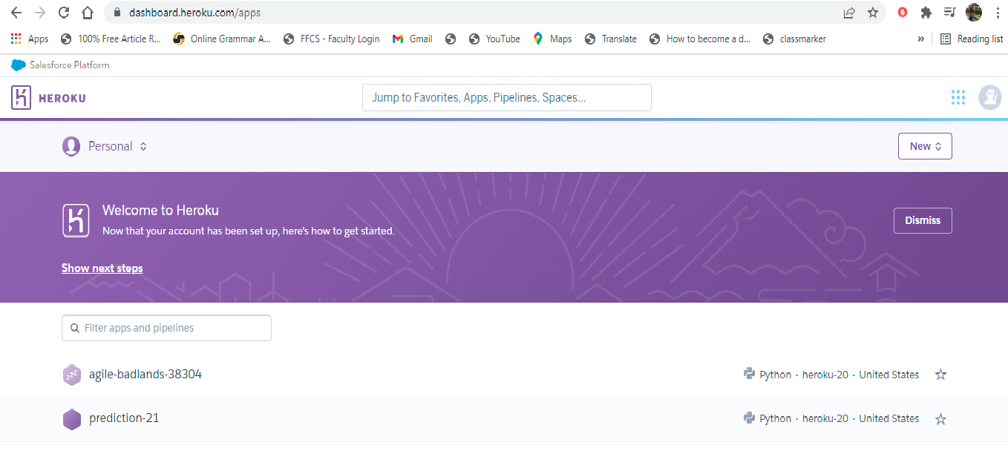

**Step 9: Link GitHub repository to Heroku app**

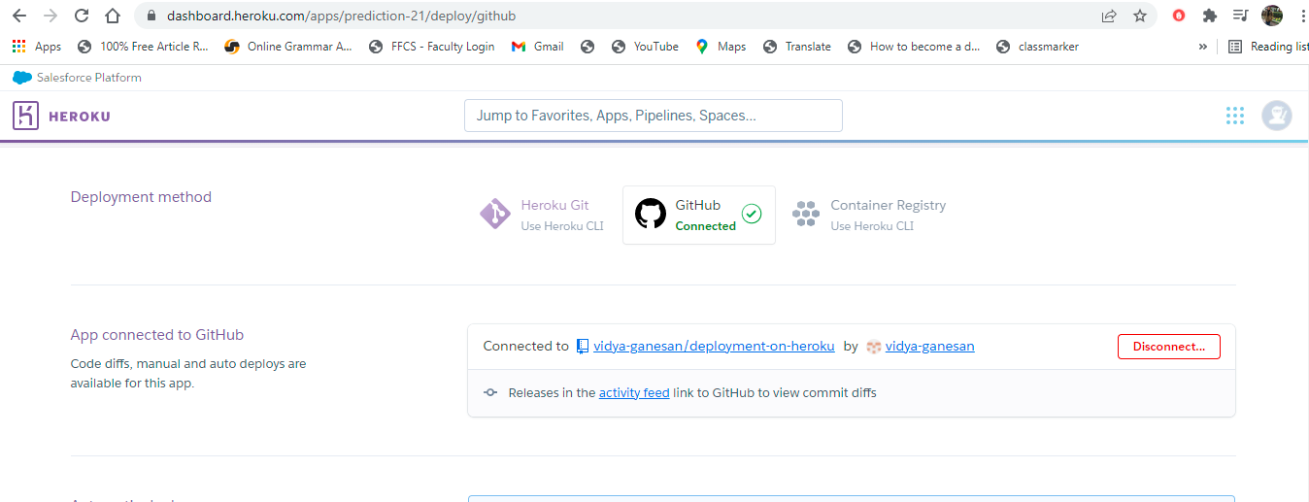

**Step 10: Deploy the model on Heroku**

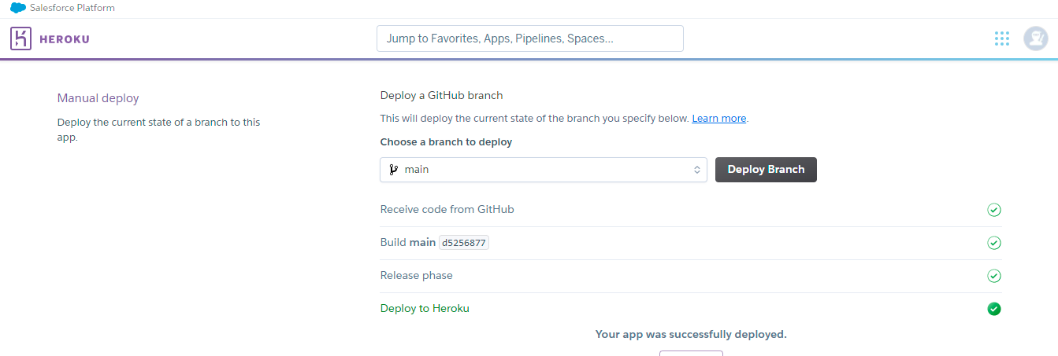

**Step 11: Run the successfully deployed app**

